FACEBOOK PROTOTYPE PROJECT
Introduction
Faceless, this project is a prototype of the Facebook application. Facebook is a social media platform that allows users to connect, share content, and interact with others online.
The aim of this project is to design and develop a simplified version of Facebook, focusing on its core features and database structure.

Purpose of the Application
The purpose of this application is to:
* Allow users to create accounts and log in
* Enable users to share posts
* Allow interaction through likes and comments
* Support connections between users (friends)

Core Features
The prototype includes the following features:
User Authentication
* Users can register an account
* Users can log in and log out
Create Posts
* Users can create text posts
* Each post is linked to a specific user
Like Posts
*Users can like posts created by other users
Comment on Posts
* Users can comment on posts
* Comments are linked to both the user and the post
Friend System
* Users can send and accept friend requests
* Users can have a list of friends

Technology Stack
The following technologies were used:
* Backend: Python (Django Framework)/ Node.js
* Database: PostgreSQL
* Frontend: HTML, CSS / React Native
* Version Control: GitHub

Database Design
The database was designed using PostgreSQL to ensure scalability and proper relationship handling.

Users Table
Stores user information.
Fields:
* id (Primary Key)
* username
* email
* password

Posts Table
Stores all user posts.
Fields:
* id (Primary Key)
* user_id (Foreign Key → Users)
* content
* created_at

Likes Table
Stores likes on posts.
Fields:
* id (Primary Key)
* user_id (Foreign Key → Users)
* post_id (Foreign Key → Posts)

Comments Table
Stores comments on posts.
Fields:
* id (Primary Key)
* user_id (Foreign Key → Users)
* post_id (Foreign Key → Posts)
* comment_text

Friends Table
Stores relationships between users.
Fields:
* id (Primary Key)
* user_id (Foreign Key → Users)
* friend_id (Foreign Key → Users)
* status (pending/accepted)
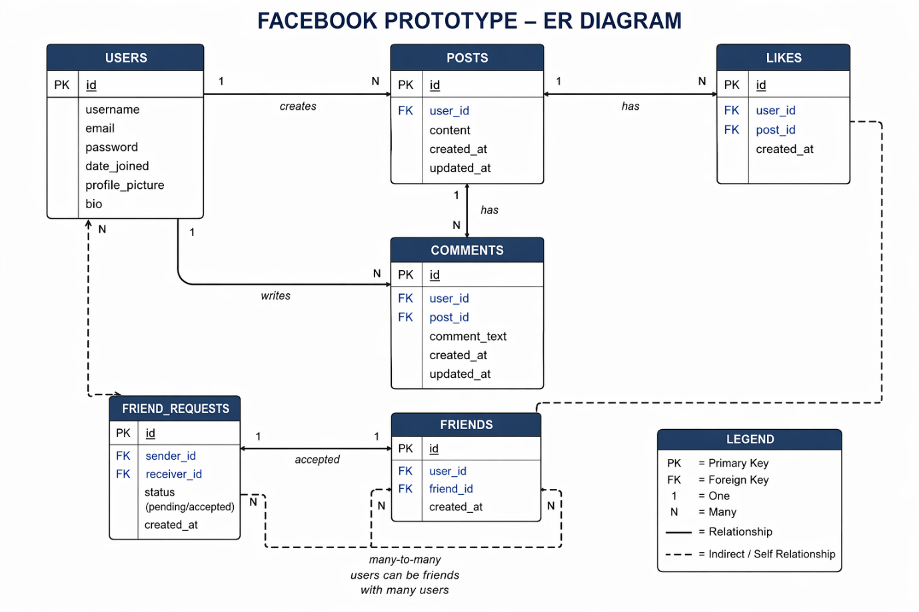

Relationships Between Tables
* One user can create many posts (One-to-Many)
* One post can have many likes (One-to-Many)
* One post can have many comments (One-to-Many)
* Users can have many friends (Many-to-Many relationship)
These relationships ensure that the application functions correctly and data is well organized.

How the System Works
1. A user registers and logs into the system
2. The user can create a post
3. Other users can like or comment on the post
4. Users can send and accept friend requests
5. All data is stored and managed in the PostgreSQL database

GitHub Repository
The project is hosted on GitHub, and access has been granted to the instructor for review.

Conclusion
This project demonstrates how a social media application like Facebook can be modeled using Django and PostgreSQL. It highlights the importance of database design, relationships, and core functionality in building scalable applications.

